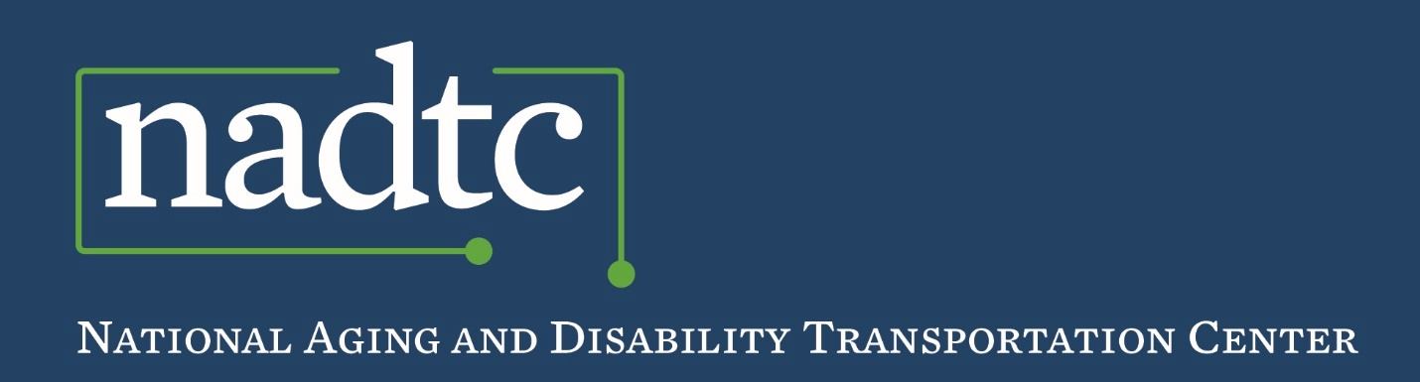Vc

*The Impact of COVID-19 on Transportation Access and Social Isolation*

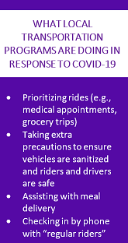We’ve long known that a lack of access to transportation can negatively affect health outcomes for older adults. In addition, a loss of independence and reduced involvement in social activities and personal hobbies brought about by not having access to transportation often results in social isolation, which also negatively impacts the health of older adults.  
  
As growing numbers of older adults become affected by stay-at-home orders as a means of social distancing to reduce the spread of COVID-19, addressing social isolation is increasingly important. What do these orders mean for older adults who need to access rides for critical medical appointments or treatment for chronic health conditions? Or for older adults who, before the COVID-19 outbreak, were dealing with loneliness and social isolation, and who are now experiencing isolation at a greater level? How are transportation providers addressing the need to connect older adults to health care and other needed services during a time when older riders are either hesitant to leave or are restricted to their homes? These are just a few of the questions on the minds of aging organizations and transportation providers that serve older adults.fsdfs

To identify the impact COVID-19 is having on access to transportation and the social isolation of older adults, the [National Aging and Disability Transportation Center](https://www.nadtc.org/) (NADTC), which is co-administered by the National Association of Area Agencies on Aging (n4a) and Easterseals, interviewed four transportation providers to learn how they are currently providing transportation to the community amid this national public health crisis. As a result of this crisis, these transportation providers are closely monitoring the impact COVID-19 is having on their communities and are continually making adjustments to keep their riders and drivers healthy and safe. Additional resources about transportation and COVID-19 are available on the NADTC website, [www.nadtc.org/covid-19-resource-center](http://www.nadtc.org/covid-19-resource-center/).

**engAGING Programs**

**Mountain Empire Older Citizens | Big Stone Gap, VA |**[www.meoc.org](http://www.meoc.org/)  
At the time of its conversation with NADTC, Mountain Empire Older Citizens (MEOC) had noted a 15 percent decline in ridership in its demand-response public transportation system. MEOC’s Call Center identifies riders who have chronic health conditions, such as dialysis patients and those receiving cancer treatment, enabling MEOC to provide rides to those with high-risk conditions separate from rides for the general public. To keep drivers and riders safe, MEOC is sanitizing its buses more frequently, at least two times per day. In addition, drivers sanitize vehicles after transporting riders who display signs of a cough before the next rider is picked up.

Because all congregate meal sites in the area are closed, MEOC has increased its home-delivered meal services. MEOC staff conduct well checks during meal deliveries and over the phone through “Good Morning, Wise County,” a program of local law enforcement in which officers call frail older adults every morning to learn whether they have a problem or need any assistance. MEOC partners with the local sheriff’s department and their dispatchers for these calls. Their AAA and transit department provide law enforcement with a list of people who are frail who they then call to check in on. These checks help MEOC learn about and address the ways increased social isolation is affecting older adults in its community.

**NV Rides | Fairfax, Virginia |**[www.nvrides.org](http://nvrides.org/)  
Through the technology it uses as part of its volunteer transportation program, NV Rides can locate alternative volunteer transportation providers to address priority ride requests. Currently, “rides of necessity” (e.g., medical and grocery trips) are continuing, with rides to dialysis and chemotherapy appointments considered to be priorities. Like many volunteer transportation programs, NV Rides relies on drivers age 65 and older to serve as volunteers, many of whom may not feel safe driving during the coronavirus crisis. As a result, NV Rides is stepping up its recruitment of younger volunteers during this critical time, to provide high priority rides or training to help older adults use technology to order groceries and other goods online.

**Volunteer Assisted Transportation (operated by Knoxville-Knox County Community Action Committee) | Knoxville, TN |**[www.knoxseniors.org/vat](http://www.knoxseniors.org/vat)  
In response to COVID-19, Volunteer Assisted Transportation (VAT) has identified rides to medical appointments and grocery stores as “priority rides” to be provided by its volunteers. VAT has experienced a reduction in ride demand, noting 40 cancellations in two days. VAT sanitizes vehicles at least once per day to ensure they are clean for the next driver on the following day. VAT has made it a standard practice to provide hand sanitizer, tissues and wipes in all vehicles. In addition to providing priority rides, VAT is working with other Knoxville-Knox County Community Action Committee programs to deliver meals and shop for clients who are unable or unwilling to leave their homes. VAT’s mobile meal delivery service and companion calls are helping to address social isolation among their riders. VAT has also committed to contacting their regular and more frequent riders who have not requested rides recently to make sure they are receiving the services they need.

**VillageRides | Montgomery County and Prince George’s County, MD |**[www.accessjca.org/villagerides](https://accessjca.org/villagerides/)  
At the time of its conversation with NADTC, VillageRides’ partner Villages have not been prioritizing rides, although medical appointments remain the top-requested destination. Some volunteers are providing non-medical rides (e.g., errands, grocery shopping) to respond to identified needs. The Villages advises volunteer drivers to take precautions by checking in with riders a day before to make sure they are not sick and by increasing sanitation practices, including cleaning door handles and other areas in their vehicles before and after rides. VillageRides noted that some Villages are experiencing a decline in ridership and are using this time as an opportunity to reach out to riders through friendly calls to check on them and learn whether they need medication or meals delivered.

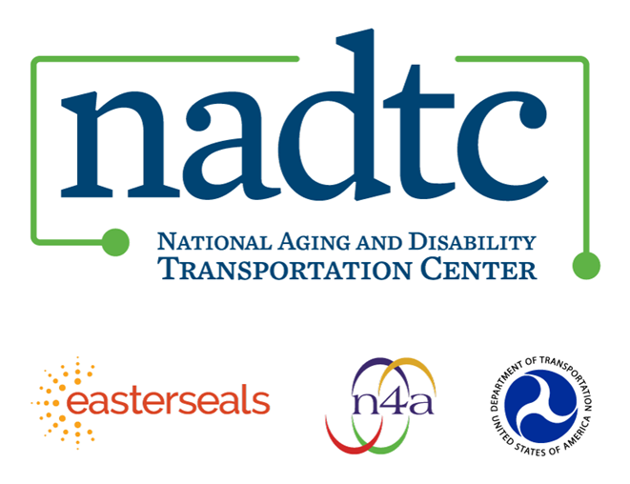

The National Aging and Disability Transportation Center (NADTC) is a program funded by the Federal Transit Administration and administered by Easterseals and the National Association of Area Agencies on Aging (n4a) with guidance from the U.S. Department of Health and Human Services, Administration for Community Living.

NADTC’s mission is to increase accessible transportation options for older adults, people with disabilities, and caregivers nationwide.

National Aging and Disability Transportation Center

Washington, D.C. 20003

Telephone and toll-free hotline: (866) 983-3222

TTY: (202) 347-7385

Email: contact@nadtc.org

Website: [www.nadtc.org](http://www.nadtc.org)

Follow us:

[Facebook](https://twitter.com/nadtcmobility)

[Twitter](https://twitter.com/nadtcmobility)

[YouTube](https://www.youtube.com/channel/UCAZ2yI_CbI-N8kMEXApeNxA)

[LinkedIn](https://www.linkedin.com/in/nadtc-staff-94a816116/)