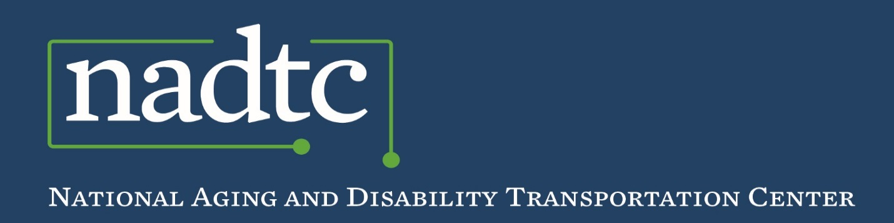

*Best Practice*

**Volunteer Best Practice:**

**Door-through-Door Volunteer Assisted Transportation**

[**Volunteer Assisted Transportation**](http://www.knoxseniors.org/vat/) (VAT) is a non-profit volunteer program of Knoxville-Knox County Community Action Committee (CAC) that provides accessible and affordable door-through-door transportation services to older adults and persons with disabilities.

A person standing next to a car

Description generated with very high confidence

**Service Area:** Volunteer Assisted Transportation serves residents in Knox County, Tennessee.

**Population:** Knox County has a population of approximately 461,860. 15% of the population is age 60 years or older.

***Challenge:*** *Limited alternative transportation programs* *providing* *additional assistance for older adults and people with disabilities before, during and after a trip.*

**How the Program Works:**

The Volunteer Assisted Transportation (VAT) program provides door-through-door transportation services for riders who require aid and assistance to travel safely. Volunteers may assist riders in their home prior to the trip, provide assistance during the course of their trip and ensure riders are safe in their home after the trip is complete. To register for the VAT program, potential riders must contact the program by phone and complete a rider application. Age or disability alone does not determine eligibility for the programs, as an individual must require assistance to travel to become a registered user of the service.

Once a rider has been determined eligible, they are be able to submit ride requests. To request a ride, riders must call the VAT office. Rides can also be requested by caregivers, family members, friends or professionals. Ride requests should be made at least 7-10 days in advance, if possible.

VAT staff will match the rider with a volunteer driver and a vehicle that is available during the time requested. Volunteer drivers can provide their availability on a shared calendar that lists the pending ride requests, call or email their availability to the program staff.

The fee for a one-way trip is $3.00 (in Knox County) and $6.00 roundtrip (in Knox County; multiple stops permitted). Ride fares for out-of-county travel will be determined on a case by case basis. Rides may be paid in cash to the volunteer driver. Alternatively, staff will mail the rider an invoice for the fare along with a self-addressed envelope at the end of the month. A caregiver, relative or friend can submit payments on behalf of the rider.

The VAT program provides volunteer assisted transportation any time a volunteer and a vehicle are available to meet a specific request. Transportation is not limited to regular business hours and there is no restriction on the purpose of the trip. Rides are available weeknights and weekends based on volunteer availability. If staff is able to match a rider, volunteer driver and vehicle, the rider is contacted to confirm their ride. Riders are also contacted when VAT is unable to fulfill a ride request. If requested, staff will assist the rider in finding an alternate means of transportation.

**Volunteers Eligibility and Training:**

Volunteer Assisted Transportation (VAT) has trained 200 volunteer drivers in the past ten years and 35 active volunteers drive monthly. To become a driver, potential volunteers must have a valid driver’s license and allow the [CAC Office on Aging](http://www.knoxcac.org/newweb/) to perform criminal and driving history background checks. Volunteers must also submit to a driver’s physical and a drug and alcohol screening (paid for by program dollars).

Volunteers drive ten agency-owned hybrid-sedans and seven wheelchair accessible minivans. Before any volunteer driver is assigned a ride, he or she must complete all parts of the Volunteer Assisted Transportation program’s volunteer driver training. Training consists of 4 separate segments: 1) the AAA Driver Improvement Program; 2) CPR/First Aid Certification; 3) Passenger Assistance & Sensitivity Training; and 4) Vehicle Orientation Training. VAT offers periodic in-service trainings, providing up-to-date information on services.

All volunteer drivers are covered under the agency’s automobile liability insurance policy. As a benefit to their volunteers, VAT offers additional insurance through the Retired Senior Volunteer Program (RSVP) program at no cost.

**Volunteer Recruitment:**

Volunteer Assisted Transportation program volunteers are recruited through their monthly newsletter, advertisements, publications and social media. Volunteers are also recruited through presentations at community organizations and by word of mouth from riders and volunteers.

**Funding:**

Volunteer Assisted Transportation (VAT) started with a development grant from the National Aging and Disability Transportation Center (NADTC), formally the National Center on Senior Transportation (NCST) in 2008.The project is funded under an agreement with the Federal Transit Administration and the Tennessee Department of Transportation and is administered by the Knoxville Regional Transportation Planning Organization. With previous Federal Transit Administration New Freedom funds, the Community Action Agency purchased hybrid vehicles and wheelchair-accessible vans. Partial funding for this project was provided through a grant awarded by the Davidson County Chancery Court, Part III from the Senior Trust/Elder Trust settlement (Case No. 11-1548-111) and through a contract administered by the Tennessee Commission on Aging and Disability. Additional funding comes from donations, fundraising and rider fees.

**Results:**

Since 2009,Volunteer Assisted Transportation (VAT) has completed 50,000 trips and has served more than 950 Knox County residents. Sixty-seven percent of program ridership is over 75 years of age and thirty-eight percent are over 85 years of age. Seventy-five percent are women and fifteen percent of riders utilize wheelchairs during their trip.

**For additional information, contact:** Warren Secrest, Program Manager, Knoxville-Knox County Community Action Committee, Volunteer Assisted Transportation. Email: [warren.secrest@cactrans.org](mailto:warren.secrest@cactrans.org) Agency website: <http://www.knoxseniors.org/vat/>

*Photo courtesy of Knoxville-Knox County Community Action Committee (CAC), Knoxville, TN*



**Who We Are**

The **National Aging and Disability Transportation Center** is funded through a cooperative agreement of Easterseals, the National Association of Area Agencies on Aging, and the U.S Department of Transportation, Federal Transit Administration, with guidance from the U.S. Department of Health and Human Services, Administration for Community Living.

The **National Association of Area Agencies on Aging (n4a)** is a 501c(3) membership association representing America’s national network of 622 Area Agencies on Aging (AAAs) and providing a voice in the nation’s capital for the 256 Title VI Native American aging programs. The mission of n4a is to build the capacity of its members so they can better help older adults and people with disabilities live with dignity and choices in their homes and communities for as long as possible. [**www.n4a.org**](http://www.n4a.org)

**Easterseals** is the leading non-profit provider of services for individuals with autism, developmental disabilities, physical disabilities and other special needs. For nearly 100 years, we have been offering help, hope, and answers to children and adults living with disabilities, and to the families who love them. Through therapy, training, education and support services, Easterseals creates life-changing solutions so that people with disabilities can live, learn, work and play.

**[www.easterseals.com](http://www.easterseals.com )**

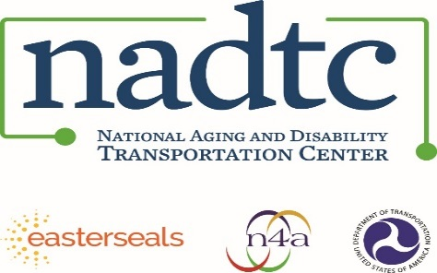

**Call toll-free:** 866.983.3222

**Email:** contact@nadtc.org

**Web:** [www.nadtc.org](http://www.nadtc.org)

**Find us** on Facebook, Twitter, YouTube & LinkedIn!

