

*Best Practice*

**Volunteer Best Practice:**

***Transportation for Homebound Older Adults***

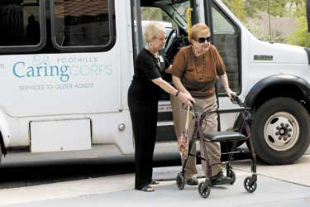[**Foothills Caring Corps**](https://foothillscaringcorps.com/)in Carefree, Arizona, is a non-profit organizationdedicated to promoting independence and enhancing the quality of life of older residents in suburban and semi-rural areas. Foothills Caring Corps provides a wide variety of services to older adults throughout the community through volunteers. The program offers services such as friendly visiting, van transportation for social outings, mobile meals and medical transportation.

**Service Area:** Foothills Caring Corps serves communities in Northeast Maricopa County, including Carefree, Cave Creek, North Phoenix and North Scottsdale.

**Population:** More than 2 million people live in Foothills Caring Corps service area. Individuals 65 years and older represent more than 14% of the population.

***Challenge:*** *There is no public transportation in 95% of the geographic area. Much of the area has limited ADA transportation services and few affordable alternatives.*

**How the Program Works:**

Foothills Caring Corps volunteers provide door to door transportation for older adults or “Neighbors,” the term commonly used in the program. Older adults or caregivers in the community that want to register for the transportation program can sign up by phone or submit an online application. A staff member will then visit the individual’s home and provide an overview of all the services offered and what best fits their needs.

The transportation program provides free round-trip rides for social outings and medical appointments. For social outing requests, riders sign up for trips based on Foothills Caring Corps’ calendar of events. A calendar of events is mailed or emailed (if requested) to the client with departure and return times and specifies the number of stops and amount of walking required. Riders must reserve their trip(s) within two weeks of receiving the calendar by calling the van transportation coordinator. A caregiver or family member can reserve a trip on behalf of the customer.

Once the event schedule is set with customer reservations, volunteer drivers are contacted by the van transportation coordinator to sign up for a trip. Once a driver is selected for the trip, an itinerary with the riders’ names and emergency telephone numbers is emailed to that volunteer. Transportation for social events are provided in Foothill Caring Corps vans.

To request medical transportation, requests are made by phone or an email to the medical transportation coordinator. Similar to scheduling volunteer drivers for social outings, drivers are contacted by the medical transportation coordinator to fulfill a ride request. Medical transportation is most often provided in the volunteer’s personal vehicle and includes door to door service. However, Foothills Caring Corps also use their wheelchair accessible vans to transport people with disabilities to medical appointments.

**Volunteer Eligibility and Training:**

Foothills Caring Corps has over 500 non-paid volunteers. Potential volunteers submit an application online or in-person at Foothill Caring Corps. Volunteer drivers must have a valid driver’s license, be finger printed and complete a criminal background check before becoming a volunteer. Van drivers receive training that includes a behind the wheel training session and basic operation of the wheelchair lifts. Only drivers with Passenger Service and Safety (PASS) certification, obtained through level ll training may transport people with disabilities in wheelchair vans with lifts. Foothills requires an assistant on all vans. This policy allows the assistant to attend to situations that may arise during the trip without distracting the driver. Foothills Caring Corps offers and encourages CPR/AED training for all volunteers. The local municipalities partner with Foothills Caring Corps in providing AARP Safe Driving Classes. The program utilizes seven vans, four of which are wheelchair accessible.

**Volunteer Recruitment:**

Volunteers are recruited through churches and community partners. In addition, Foothills Caring Corps sets up displays and booths at many local events with information to sign up potential volunteers. The organization utilizes local papers and magazines to advertise. However, they have discovered that word of mouth in small communities is the most successful method for recruitment. Foothills Caring Corps holds a general volunteer orientation every second Thursday of the month to give an overview of the program, as well as policies and procedures.

**Funding:** Foothill Caring Corps’ operational costs are fully covered through fundraising events, individual donations, corporate gifts, and grants. Foothills Caring Corps’ vans for their van transportation program are funded through the section 5310 program. They have an annual operating budget approaching $1 million.

**Results:** Foothills Caring Corps provided a grand total 12,673 rides in 2017-18. The van program provided 8,159 trips and 4,514 trips for medical transportation.

**For additional information, contact:** Debbra Determan, Executive Director. Phone: (480) 488-1105%20488-1105). **Agency Website:** <https://foothillscaringcorps.com/>

*Photo courtesy of Foothills Caring Corps, Carefree, Arizona*



**Who We Are**

The **National Aging and Disability Transportation Center** is funded through a cooperative agreement of Easterseals, the National Association of Area Agencies on Aging, and the U.S Department of Transportation, Federal Transit Administration, with guidance from the U.S. Department of Health and Human Services, Administration for Community Living.

The **National Association of Area Agencies on Aging (n4a)** is a 501c(3) membership association representing America’s national network of 622 Area Agencies on Aging (AAAs) and providing a voice in the nation’s capital for the 256 Title VI Native American aging programs. The mission of n4a is to build the capacity of its members so they can better help older adults and people with disabilities live with dignity and choices in their homes and communities for as long as possible. [**www.n4a.org**](http://www.n4a.org)

**Easterseals** is the leading non-profit provider of services for individuals with autism, developmental disabilities, physical disabilities and other special needs. For nearly 100 years, we have been offering help, hope, and answers to children and adults living with disabilities, and to the families who love them. Through therapy, training, education and support services, Easterseals creates life-changing solutions so that people with disabilities can live, learn, work and play. [**www.easterseals.com**](http://www.easterseals.com/)

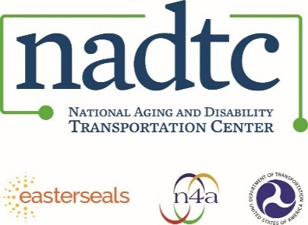

**Call toll-free:** 866.983.3222

**Email:** contact@nadtc.org

**Web:** [www.nadtc.org](http://www.nadtc.org)

**Find us** on Facebook, Twitter, YouTube & LinkedIn! 